**LAPORAN TEORI 7**

**STRUKTUR DATA**

**Indra Fajar Nurwahid**

**2231740006**

**1B**



**TEKNOLOGI INFORMASI**

**POLITEKNIK NEGERI MALANG KAMPUS LUMAJANG**

*Jl. Lintas Timur, Area Sawah/Kebun, Jogotrunan, Kec. Lumajang, Kabupaten Lumajang, Jawa Timur 67314*

**2023**

# KATA PENGANTAR

Assalamu’alaikum warahmatullahi wabarakatuh

Segala puji bagi Allahh SWT yang telah memberikan kami kemudahan sehingga kami dapat menyelesaikan makalah ini dengan tepat waktu. Tanpa pertolongan-Nya tentunya kami tidak sanggup untuk menyelesaikan makalah ini dengan baik. Shalawat serta salam semoga terlimpah curahkan kepada baginda tercinta kita yaitu Nabi Muhammad SAW yang kita nanti-nantikan syafaatnya di akhirat nanti

Penulis mengucapkan syukur kepada Allah SWT atas limpahan nikmat sehat-Nya, baik itu berupa sehat fisik maupun akal pikiran, sehingga penulis mampu untuk menyelesaikan pembuatan makalah dengan judul “LAPORAN TEORI 7

STRUKTUR DATA”

Penulisa tentu menyadari bahwa makalah ini masih banyak terdapat kesalahan serta kekurangan si dalamnya, untuk itu, penulis berharap mendpatkan kritik dan saran yang membangun bagi perbaikan makalah kami selanjutnya.Demikian makalah ini kami buat, apabila terdapat kesalahan dalam penulisan, ataupun adanya ketidaksesuaian materi yang kami angkatpada makalah ini, kami mohon maaf. Tim penulis menerima kritik dan saran seluas-luasnya daripembaca agar bias membuat karya makalah yang lebih baik pada kesempatan berikutnya

Lumajang, 3 April 2023

Penulis

**Daftar Isi**

KATA PENGANTAR i

No. 1 1

No. 2 1

No. 3 3

Insertion Sort Ascending 4

Shell Short Ascending 5

# No. 1

Insertion Sort Ascending

Data = {2,35,14,27,67,19,23,46}

awal

|  |  |  |  |  |  |  |  |
| --- | --- | --- | --- | --- | --- | --- | --- |
| 2 | 35 | 14 | 27 | 67 | 19 | 23 | 46 |

|  |  |  |  |  |  |  |  |
| --- | --- | --- | --- | --- | --- | --- | --- |
| 2 | 35 | 14 | 27 | 67 | 19 | 23 | 46 |

|  |  |  |  |  |  |  |  |
| --- | --- | --- | --- | --- | --- | --- | --- |
| 2 | 14 | 35 | 27 | 67 | 19 | 23 | 46 |

|  |  |  |  |  |  |  |  |
| --- | --- | --- | --- | --- | --- | --- | --- |
| 2 | 14 | 35 | 27 | 67 | 19 | 23 | 46 |

|  |  |  |  |  |  |  |  |
| --- | --- | --- | --- | --- | --- | --- | --- |
| 2 | 14 | 19 | 35 | 27 | 67 | 23 | 46 |

|  |  |  |  |  |  |  |  |
| --- | --- | --- | --- | --- | --- | --- | --- |
| 2 | 14 | 19 | 23 | 35 | 27 | 67 | 46 |

|  |  |  |  |  |  |  |  |
| --- | --- | --- | --- | --- | --- | --- | --- |
| 2 | 14 | 19 | 23 | 27 | 35 | 67 | 46 |

|  |  |  |  |  |  |  |  |
| --- | --- | --- | --- | --- | --- | --- | --- |
| 2 | 14 | 19 | 23 | 27 | 35 | 67 | 46 |

|  |  |  |  |  |  |  |  |
| --- | --- | --- | --- | --- | --- | --- | --- |
| 2 | 14 | 19 | 23 | 27 | 35 | 46 | 67 |

# No. 2

Shell Sort Descending

Data = {89,14,67,9,65,25,78,17}

awal

|  |  |  |  |  |  |  |  |
| --- | --- | --- | --- | --- | --- | --- | --- |
| 89 | 14 | 67 | 9 | 65 | 25 | 78 | 17 |

Jarak = 4

|  |  |  |  |  |  |  |  |
| --- | --- | --- | --- | --- | --- | --- | --- |
| 89 | 14 | 67 | 9 | 65 | 25 | 78 | 17 |

|  |  |  |  |  |  |  |  |
| --- | --- | --- | --- | --- | --- | --- | --- |
| 89 | 25 | 67 | 9 | 65 | 14 | 78 | 17 |

|  |  |  |  |  |  |  |  |
| --- | --- | --- | --- | --- | --- | --- | --- |
| 89 | 25 | 78 | 9 | 65 | 14 | 67 | 17 |

|  |  |  |  |  |  |  |  |
| --- | --- | --- | --- | --- | --- | --- | --- |
| 89 | 25 | 78 | 17 | 65 | 14 | 67 | 9 |

Jarak = 4/2 = 2

|  |  |  |  |  |  |  |  |
| --- | --- | --- | --- | --- | --- | --- | --- |
| 89 | 25 | 78 | 9 | 65 | 14 | 67 | 17 |

|  |  |  |  |  |  |  |  |
| --- | --- | --- | --- | --- | --- | --- | --- |
| 89 | 25 | 78 | 9 | 65 | 14 | 67 | 17 |

|  |  |  |  |  |  |  |  |
| --- | --- | --- | --- | --- | --- | --- | --- |
| 89 | 25 | 78 | 9 | 65 | 14 | 67 | 17 |

|  |  |  |  |  |  |  |  |
| --- | --- | --- | --- | --- | --- | --- | --- |
| 89 | 25 | 78 | 9 | 65 | 14 | 67 | 17 |

|  |  |  |  |  |  |  |  |
| --- | --- | --- | --- | --- | --- | --- | --- |
| 89 | 25 | 78 | 14 | 65 | 9 | 67 | 17 |

|  |  |  |  |  |  |  |  |
| --- | --- | --- | --- | --- | --- | --- | --- |
| 89 | 25 | 78 | 14 | 67 | 9 | 65 | 17 |

|  |  |  |  |  |  |  |  |
| --- | --- | --- | --- | --- | --- | --- | --- |
| 89 | 25 | 78 | 14 | 67 | 17 | 65 | 9 |

|  |  |  |  |  |  |  |  |
| --- | --- | --- | --- | --- | --- | --- | --- |
| 89 | 25 | 78 | 14 | 67 | 17 | 65 | 9 |

Jarak = 2/2 = 1

|  |  |  |  |  |  |  |  |
| --- | --- | --- | --- | --- | --- | --- | --- |
| 89 | 78 | 25 | 14 | 67 | 17 | 65 | 9 |

|  |  |  |  |  |  |  |  |
| --- | --- | --- | --- | --- | --- | --- | --- |
| 89 | 78 | 25 | 67 | 14 | 17 | 65 | 9 |

|  |  |  |  |  |  |  |  |
| --- | --- | --- | --- | --- | --- | --- | --- |
| 89 | 78 | 25 | 67 | 17 | 14 | 65 | 9 |

|  |  |  |  |  |  |  |  |
| --- | --- | --- | --- | --- | --- | --- | --- |
| 89 | 78 | 25 | 67 | 17 | 65 | 14 | 9 |

|  |  |  |  |  |  |  |  |
| --- | --- | --- | --- | --- | --- | --- | --- |
| 89 | 78 | 67 | 25 | 17 | 65 | 14 | 9 |

|  |  |  |  |  |  |  |  |
| --- | --- | --- | --- | --- | --- | --- | --- |
| 89 | 78 | 67 | 25 | 65 | 17 | 14 | 9 |

|  |  |  |  |  |  |  |  |
| --- | --- | --- | --- | --- | --- | --- | --- |
| 89 | 78 | 67 | 65 | 25 | 17 | 14 | 9 |

# No. 3

## Insertion Sort Ascending

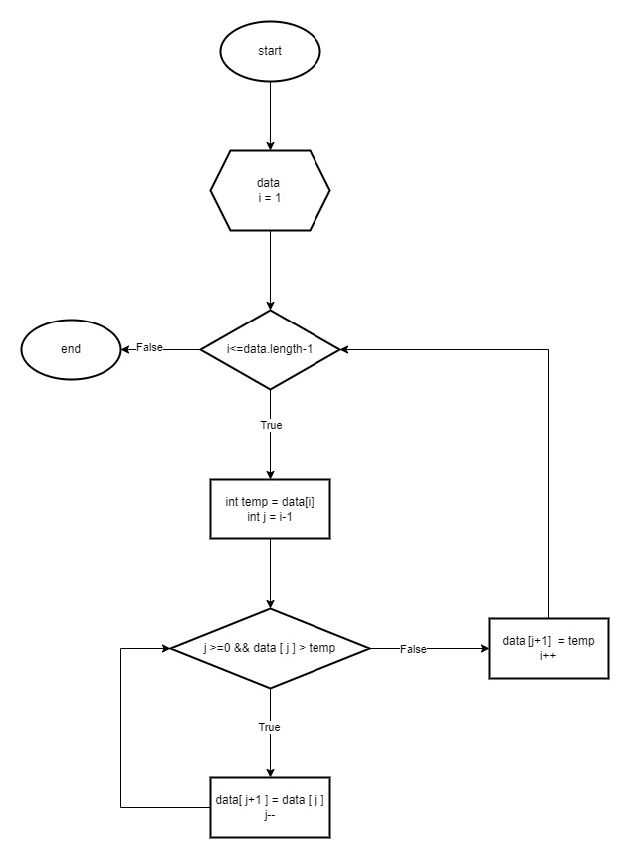

## Shell Short Ascending

